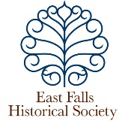

**East Falls Historical Society**

**Membership Renewal – May 2024 – May 2025**

**Please join or renew your membership online (below)**

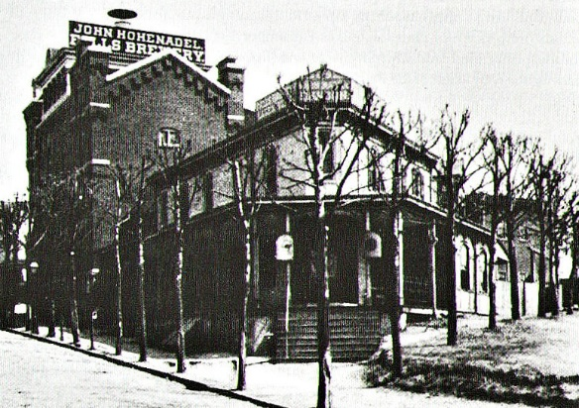

**Now in our 21st year, we continue to preserve the rich, unique history of East Falls.**

**Our 2023 - 2024 Achievements**

***Three Walking Tours:***

**The Oak Road, the John Dobson Walk, and** **Historic Mt. Vernon Cemetery**

***Programs:***

**Iron Works at Pencoyd Landing;** **Personal Archiving Drop-Ins; Reporting East Falls: A History of Local**

**Newspapers** **(zoom); &, with East Falls Village: The History of Public Restrooms, A Story of Inequality;**

**and the Sesqui-Centennial Exposition of 1926: The Ladies of the Street.**

***Advocacy* for preservation of local historic sites**

**- *Oral history interviews* of long-time residents of East Falls** (available on our website).

**- *Acquisitions* of local historic photographs, newspapers and artifacts**

**- *Website enhancements* and added resources** (www.eastfallshistoricalsociety.org)

**- *Local history columns*, monthly**, in ***East Falls Now***

**- *Research* for reference queries and planning our new Online History Project**

**Thank you for supporting the EFHS! (a 501C3 organization)**

**Click here** **to renew your membership with PayPal, OR**

**Print and mail the form below with your check, payable to East Falls Historical Society**

**Katy Hineline, 600 E. Cathedral Road Apt. D305, Philadelphia, PA 19128**

********************************************************************************************************************************  
**Yes, I want to renew my EFHS membership.           May 2024 - May 2025**

Name___________________________________ Address _________________________________________

Telephone__________________________ Email________________________________________________

**Membership:**  Individual $15 _____ Patron $25_____ Sponsor $35 _____ Benefactor $50 ______

Organization $75_____  Other _____

**Committees of Interest:** (please circle)  Acquisitions    Archiving    Preservation    Public Relations   Funding

Historic Sites    Oral History    Programs   Reference    Research Website